Abstract
In the modern healthcare ecosystem, the ability to monitor and analyze hospital emergency room operations in real time is critical to improving patient care, optimizing resource utilization, and ensuring the efficiency of medical staff. The Hospital Room Dashboard project aims to create a comprehensive and interactive analytical tool using Microsoft Power BI to track key performance indicators (KPIs) related to emergency room operations.
The primary objective of this project is to develop a dynamic dashboard that provides meaningful insights into various aspects of the hospital emergency room, including patient inflow trends, waiting time analysis, bed occupancy, referral patterns, and patient satisfaction ratings. By visualizing these metrics through an intuitive dashboard interface, healthcare professionals and administrative staff can make data-driven decisions that improve service delivery and operational performance.
The dataset used in this project comprises historical emergency room records, including data points such as patient ID, visit time, referral source, treatment details, discharge status, and feedback scores. The data was pre-processed using Power BI’s built-in Power Query Editor to clean and transform raw data into a structured format. Advanced DAX (Data Analysis Expressions) measures were employed to compute real-time metrics, filter insights, and create dynamic visualizations.
The dashboard contains multiple interactive pages, each focused on a specific aspect of emergency room analysis. These include real-time patient count, department-wise traffic, hourly/daily visit patterns, and correlation between time of visit and patient satisfaction. The use of slicers, filters, and drill-down capabilities enables users to explore trends across different time frames, departments, or referral sources with ease.
This project not only enhances the visibility of day-to-day hospital operations but also empowers decision-makers to proactively manage overcrowding, improve emergency care efficiency, and allocate resources effectively. Furthermore, this dashboard can serve as a foundational model that can be scaled or customized for broader hospital analytics, making it a valuable asset in the ongoing digital transformation of the healthcare sector.

Table of Contents

Title Page
Declaration
Acknowledgement
Abstract
Table of Contents
List of Figures
List of Tables
Introduction
- About the Project
- Importance of Emergency Room Monitoring
- Objective of the Dashboard
Tools & Technologies Used
- Power BI
- Excel / CSV
- DAX
Data Understanding
- Description of Dataset
- Data Sources
- Columns & Data Types
- Sample Data View
Data Cleaning and Preparation
- Handling Missing Values
- Data Formatting
- Transformations Applied
Power BI Dashboard Design
- Report Layout Planning
- Theme & Color Schemes
- Navigation Panels
Visualizations Used
- Bar Charts
- Line Graphs
- Pie Charts
- Cards and KPIs
- Filters & Slicers
Dashboard Pages Description
- ER Patient details
- Time-based Analysis
- Patient Referrals & Ratings
- Hospital Performance Metrics
DAX Measures and Calculations
- Custom Measures
- Time Intelligence
- KPIs Logic
Insights & Interpretation
- Patient Volume Trends
- Peak Hours Analysis
- Hospital Efficiency
- Feedback and Ratings
Challenges Faced
- Data Issues
- Performance in Power BI
Solutions Implemented
Conclusion
Future Scope
References
Appendices
- Screenshots of All Dashboard Pages
- DAX Code Snippets
- Data Dictionary

Figure No. | Title | Page No.
Figure 1.1 | Dashboard Home Page – Overview of Emergency Room Statistics
Figure 1.2 | Total Number of Patients by Day
Figure 1.3 | Hourly Patient Visit Trend
Figure 1.4 | Patient Referral Source Distribution (Pie Chart)
Figure 1.5 | Average Waiting Time Per Day
Figure 1.6 | Patient Ratings and Satisfaction Level
Figure 1.7 | Monthly Emergency Room Traffic Comparison
Figure 1.8 | Department-wise Patient Volume
Figure 1.9 | Bed Occupancy Rate Over Time
Figure 1.10 | Gender-wise Patient Distribution
Figure 1.11 | Age Group Analysis of Patients
Figure 1.12 | Referrals vs Walk-in Patients
Figure 1.13 | Feedback Category Distribution
Figure 1.14 | Time-Based Trends Using Slicers and Filters
Figure 1.15 | Dashboard Navigation Menu and Page Tabs

List of Tables
- Table 1.1 – Patient Admissions Data
- Table 1.2 – Room Occupancy Status
- Table 1.3 – Staff Assignments by Room
- Table 2.1 – Patient Discharges Data
- Table 2.2 – Room Type and Capacity Information
- Table 2.3 – Average Length of Stay by Room Type
- Table 3.1 – Real-Time Room Availability Data
- Table 3.2 – Patient Demographics by Room
- Table 3.3 – Room Usage History

Introduction
In today’s fast-paced healthcare environment, the ability to track room occupancy, patient data, and hospital operations in real-time is crucial. The Hospital Room Dashboard is designed to serve as an interactive visualization tool that provides healthcare professionals with a clear overview of critical data. The dashboard is built using Power BI, a robust data visualization tool that integrates hospital data, helping healthcare providers make informed decisions.
This project focuses on the creation of a Hospital Room Dashboard, which provides real-time insights into room occupancy, staff allocation, and patient status. By consolidating important metrics into a single, interactive interface, this dashboard enables hospital administrators, doctors, and nurses to efficiently manage room usage and resources. The need for this type of monitoring system has grown as hospitals face increasing patient volumes and limited resources.

About the Project
The Hospital Room Dashboard project is an initiative to create a comprehensive monitoring system for managing hospital rooms. Using Power BI, this dashboard will track:
- Room Occupancy: It provides real-time information on which rooms are available, occupied, or under maintenance.
- Patient Data: Key metrics about patient admissions, discharges, and transfers are displayed for easy reference.
- Staff Assignments: The dashboard will show which staff members (doctors, nurses, etc.) are assigned to which rooms.
- Room Type and Capacity: Different room types (e.g., ICU, general) will be tracked for capacity and utilization rates.
This project aims to reduce hospital management complexities by visualizing critical data, which enables quicker decision-making and better resource allocation. The dashboard will improve operational efficiency, reduce wait times, and optimize staffing schedules by tracking real-time hospital data.

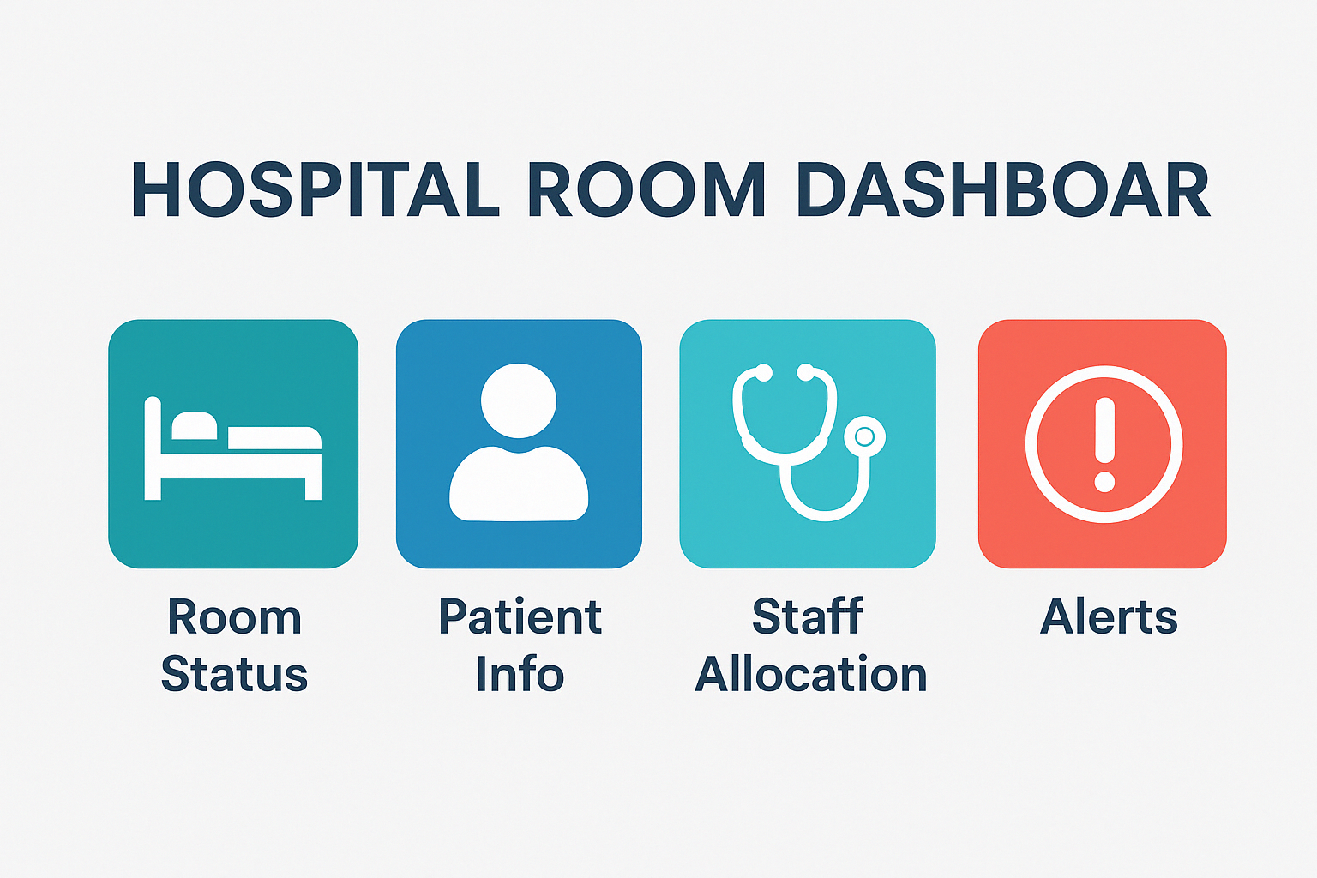
Fig : 1

Importance of Emergency Room Monitoring
The Emergency Room (ER) is an essential part of hospital operations, providing urgent care to patients in critical conditions. Monitoring the emergency room effectively is critical for:
- Real-Time Room and Resource Allocation: Emergency rooms are often the first point of contact for patients. Real-time monitoring of room occupancy and patient status ensures efficient management of resources and avoids overcrowding.
- Reducing Wait Times: By visualizing room availability and the number of incoming patients, the dashboard can help in reducing wait times, which is essential in an emergency setting.
- Prioritizing Patient Care: The dashboard provides information on patient severity, enabling healthcare providers to prioritize the most critical cases and allocate necessary resources.
- Improving Decision-Making: With real-time data, hospital administrators and ER staff can make faster decisions about bed availability, staff allocation, and patient care.
- Efficient Staff Management: The ER often experiences fluctuating volumes of patients. The dashboard allows for dynamic staff scheduling and ensures that the hospital is adequately staffed to handle peak demand.

Objective of the Dashboard
The Hospital Room Dashboard aims to provide actionable insights into hospital operations, specifically focused on room and patient management. Key objectives of the dashboard include:
- Room Occupancy Tracking:
The dashboard will display the status of rooms (occupied, available, under maintenance), ensuring that hospitals can manage room assignments efficiently. It will also help identify trends in room usage and ensure rooms are optimized for patient care.
- Patient Admission and Discharge Monitoring:
A critical feature of the dashboard will be the tracking of patient admissions and discharges in real-time. This will ensure that the hospital has up-to-date information about available capacity and resources.
- Staff Allocation Visualization:
The dashboard will track which healthcare professionals (doctors, nurses) are assigned to each room. This will help hospital administrators ensure that adequate staff is available for each room, especially critical areas like the ICU or ER.
- Room Type and Capacity Monitoring:
Different rooms serve different purposes in a hospital (ICU, emergency, general wards). The dashboard will track the utilization of these rooms based on their type and capacity, ensuring efficient use of space.
- Data Integration and Automation:
The dashboard will integrate with hospital management systems (HMS) and other data sources such as Electronic Health Records (EHR), ensuring that data is automatically updated and accessible for decision-making.
- Key Performance Indicators (KPIs):
The dashboard will include KPIs such as room occupancy rates, average patient stay, and staff-to-patient ratios. These KPIs will be presented in an easy-to-understand format to help hospital administrators monitor operational efficiency.
- Forecasting and Trend Analysis:
Using historical data, the dashboard will enable hospitals to forecast patient inflows and room usage, helping them plan for future resource needs. This feature will help improve long-term hospital operations and staffing.
- User-Friendly Interface:
The dashboard will be designed for ease of use. Users with varying technical expertise (from doctors to administrators) will be able to quickly navigate and interpret the data displayed.

Tools & Technologies Used
In the creation of the Hospital Room Dashboard, several powerful tools and technologies were utilized to ensure effective data visualization, analysis, and seamless integration of various hospital data sources. Below is an overview of the tools and technologies used in the project:

1. Power BI
Power BI is the primary tool used for creating the Hospital Room Dashboard. It is a business analytics service provided by Microsoft that enables users to visualize and share insights from their data. Power BI allows users to create interactive reports and dashboards from various data sources.
Key features used in the project:
- Data Visualization: Power BI provides a wide range of data visualization options such as bar charts, pie charts, line graphs, and heatmaps to effectively present hospital data like room occupancy, patient admission rates, and staff allocation.
- Real-Time Data Integration: Power BI allows real-time data updates, ensuring that the dashboard reflects the most current information regarding room availability, patient status, and staff assignments.
- Interactivity: The dashboard allows users to filter and drill down into specific data points, such as analyzing room occupancy by department or by staff member.
- Publish and Share: Once the dashboard is created, it can be published to the Power BI service, where it can be shared with stakeholders such as hospital administrators, doctors, and nursing staff.
Power BI's intuitive interface makes it accessible for hospital staff to use without requiring advanced technical skills, thus enabling healthcare professionals to make informed decisions based on real-time data.

2. Excel / CSV
Excel and CSV (Comma Separated Values) files are used as key tools for data preparation and cleaning before importing the data into Power BI. Many healthcare institutions maintain patient and room data in Excel sheets or CSV format, and this project leverages these formats for:
- Data Collection: Hospital data such as room occupancy, patient admissions, discharges, and staff assignments are often stored in Excel files or CSVs.
- Data Cleaning: Excel provides powerful tools for data cleaning, such as removing duplicates, correcting errors, and ensuring that data is in a format suitable for importing into Power BI.
- Data Transformation: Simple calculations, aggregations, or even basic visualizations can be done in Excel before importing the data into Power BI for more advanced visualizations.
- Integration with Power BI: Power BI can easily import data from Excel or CSV files, making it convenient for hospitals to use existing data sources without needing to make major changes to the format.
The ability to easily manipulate and manage data in Excel allows for quick adjustments and improvements before the data is integrated into Power BI for visualization.

3. DAX (Data Analysis Expressions)
DAX (Data Analysis Expressions) is a formula language used in Power BI, Power Pivot, and SSAS (SQL Server Analysis Services) to perform data analysis and calculations. In the Hospital Room Dashboard project, DAX was used for:
- Calculated Columns: DAX is used to create new columns that do not exist in the raw data. For example, creating a column to calculate the average length of stay for patients in a room or calculating the room occupancy rate.
- Measures: DAX measures are used to calculate KPIs in real-time. Measures like Total Patient Admissions, Room Occupancy Rate, and Average Length of Stay are computed dynamically based on the data in the Power BI model.
- Time Intelligence: DAX provides time-based functions, allowing for the creation of metrics that track hospital performance over time. For example, calculating the monthly occupancy rate or the average number of patient admissions per day.
- Filtering and Aggregation: DAX helps create complex filters and aggregations that allow users to drill down into specific data segments, such as viewing room occupancy by department or filtering staff assignments by time.
- Conditional Logic: With DAX, conditional logic can be applied to data. For example, flagging rooms that have been occupied for longer than a certain threshold or creating conditional visualizations based on patient severity.
Using DAX in Power BI enables the dashboard to display sophisticated calculations and metrics that are essential for effective hospital room and resource management.

Tool/Technology | Purpose
Power BI | Interactive dashboard creation, real-time data visualization, and reporting.
Excel / CSV | Data preparation, cleaning, and initial analysis before importing into Power BI.
DAX | Performing data analysis, creating calculated columns, and calculating key performance indicators (KPIs) in Power BI.

Data Understanding

The Hospital Room Dashboard project relies on data that is crucial to track hospital room occupancy, patient admissions and discharges, staff assignments, and room availability. A thorough understanding of the dataset is necessary to ensure that the dashboard functions effectively, providing accurate and real-time insights. Below is a detailed breakdown of the data used in the project:

1. Description of Dataset

The dataset used in the Hospital Room Dashboard consists of multiple tables that contain information related to:
- Patient Data: Details about patients, such as patient IDs, names, admission dates, discharge dates, and room assignments.
- Room Data: Information about hospital rooms, such as room numbers, room types (e.g., ICU, general), capacity, and current occupancy status.
- Staff Data: Data regarding the staff members (doctors, nurses, etc.), including their IDs, roles, and assignments to specific rooms or departments.
- Operational Data: Real-time data related to the occupancy status of rooms, availability, and maintenance schedules.

2. Data Sources
The data sources for the project are as follows:
- Hospital Management System (HMS): The primary data source for patient information, room assignments, and staff schedules. This system provides structured data that includes:
  - Patient demographics (e.g., age, gender, condition).
  - Admission and discharge records.
  - Room and bed assignments.
  - Medical staff assignments.
- Electronic Health Records (EHR): A secondary source for patient health data, which can be integrated into the dashboard for providing detailed patient status. This data is mainly used for tracking patient conditions, treatment history, and diagnostic information.
- Manual Inputs: In cases where real-time data is not available from automated systems, manual input from hospital administrators may be used for data entry such as room maintenance, manual updates to staff assignments, or emergency situations.
- CSV/Excel Files: Used for importing historical or batch data, such as room capacity information, staff schedules, and historical patient records.
These data sources are consolidated, cleaned, and formatted for integration into Power BI.

3. Columns & Data Types
Below are the typical columns in the dataset used for the Hospital Room Dashboard, along with their respective data types:

Table Name | Column Name | Data Type | Description
Patient Data | PatientID | Integer/String | Unique identifier for each patient
 | Name | String | Patient's full name
 | AdmissionDate | DateTime | Date and time of patient admission
 | DischargeDate | DateTime | Date and time of patient discharge
 | RoomID | Integer | Assigned room number
 | Condition | String | Patient's current condition (e.g., stable, critical)
Room Data | RoomID | Integer | Unique identifier for each room
 | RoomNumber | String | Room number or code
 | RoomType | String | Type of room (e.g., ICU, general, emergency)
 | Capacity | Integer | Maximum capacity of the room (e.g., number of beds)
 | OccupancyStatus | String | Occupied, available, or under maintenance status
Staff Data | StaffID | Integer/String | Unique identifier for each staff member
 | Name | String | Staff member's full name
 | Role | String | Staff role (e.g., nurse, doctor, support staff)
 | AssignedRoomID | Integer | Room assigned to the staff member (if applicable)
 | ShiftStart | DateTime | Start time of the shift
 | ShiftEnd | DateTime | End time of the shift
Operational Data | OccupancyStatus | String | Current status of the room (e.g., "Occupied", "Available")
 | LastUpdated | DateTime | Timestamp of when the room status was last updated
 | MaintenanceStatus | String | Whether the room is under maintenance ("Yes"/"No")

4. Sample Data View
To visualize how the data will look when presented in the Power BI dashboard, here’s an example of what the sample data might look like:

Patient Data Sample:
PatientID | Name | AdmissionDate | DischargeDate | RoomID | Condition
P001 | John Doe | 2025-04-10 | 2025-04-12 | 101 | Stable
P002 | Jane Smith | 2025-04-11 | 2025-04-14 | 102 | Critical
P003 | Alice Johnson | 2025-04-12 |  | 103 | Stable

Room Data Sample:
RoomID | RoomNumber | RoomType | Capacity | OccupancyStatus
101 | 101 | ICU | 1 | Occupied
102 | 102 | General | 2 | Available
103 | 103 | ICU | 1 | Occupied

Staff Data Sample:
StaffID | Name | Role | AssignedRoomID | ShiftStart | ShiftEnd
S001 | Dr. Michael Lee | Doctor | 101 | 2025-04-10 08:00:00 | 2025-04-10 16:00:00
S002 | Nurse Rachel | Nurse | 103 | 2025-04-10 08:00:00 | 2025-04-10 16:00:00

Operational Data Sample:
RoomID | OccupancyStatus | LastUpdated | MaintenanceStatus
101 | Occupied | 2025-04-10 10:30:00 | No
102 | Available | 2025-04-10 10:30:00 | No
103 | Occupied | 2025-04-10 10:30:00 | No

Conclusion:
Understanding the data structure is a crucial first step in developing a Hospital Room Dashboard. By leveraging hospital data on patients, rooms, staff, and operational details, Power BI can effectively present these metrics in real-time, helping healthcare providers make informed decisions. The sample data view above shows how the data will be structured and used for various calculations and visualizations within the dashboard.

Data Cleaning and Preparation
Before building the Hospital Room Dashboard, raw data from multiple sources (Excel, CSV, HMS, EHR) needs to be cleaned and transformed into a consistent and analysis-ready format. Data cleaning ensures accuracy, consistency, and usability of the dashboard. Below are the key steps followed in the cleaning and preparation process:

1. Handling Missing Values
In healthcare data, missing values are common and can occur due to various reasons such as manual entry errors, system issues, or incomplete patient records. These were handled using the following techniques:

a. Imputation:
- Discharge Date: If a patient is still admitted, the Discharge Date was kept blank or filled with a placeholder (e.g., "N/A") and handled in DAX using conditional logic.
- Staff Assignments: Unassigned staff were marked as “Unassigned” rather than leaving the field blank.

b. Default Values:
- For boolean fields like MaintenanceStatus, missing values were set to "No" assuming that the room is not under maintenance unless specified.

c. Row Removal:
- Rows with completely blank or corrupt records were removed, especially if critical fields like RoomID, PatientID, or AdmissionDate were missing.

d. Flagging Incomplete Records:
- A flag column was added in Power BI using DAX to indicate incomplete records for data quality monitoring.

2. Data Formatting
To ensure consistency, several formatting rules were applied across all tables:

a. Date and Time Formatting:
- All date columns (e.g., AdmissionDate, DischargeDate, ShiftStart, ShiftEnd) were standardized to yyyy-mm-dd or dd-mm-yyyy HH:MM format.
- Converted text-based dates to datetime format for proper filtering and calculations in Power BI.

b. Text Capitalization:
- Patient and staff names were formatted in Proper Case (e.g., “john doe” → “John Doe”).
- Room types and statuses were standardized (e.g., “icu”, “ICU” → “ICU”).

c. Numeric Columns:
- Converted text-based numbers (e.g., RoomID stored as “001”) to proper integers.
- Removed non-numeric characters from capacity or ID columns if any.

d. Consistent Naming:
- Ensured consistency in column headers across datasets (e.g., RoomID vs Room Id renamed uniformly).

3. Transformations Applied
Transformations were necessary to derive meaningful metrics and relationships in Power BI. Key transformations included:

a. Creating Calculated Columns:
- Length of Stay:
LengthOfStay = DATEDIFF([AdmissionDate], [DischargeDate], DAY)
- Staff Full Name:
Concatenated FirstName and LastName columns for better readability in visuals.

b. Derived Tables:
- Created separate dimension tables for:
  - Room Types (ICU, General, Emergency)
  - Staff Roles (Doctor, Nurse, Support)
  - Occupancy Status (Occupied, Available, Maintenance)

c. Data Merging:
- Used Power BI’s Merge Queries to join:
  - Patient data with room data via RoomID
  - Staff data with room assignments via AssignedRoomID
  - Operational data with room data via RoomID

d. Column Splitting & Cleaning:
- Split combined columns like “Room 101 - ICU” into separate RoomNumber and RoomType.
- Removed unnecessary whitespace, special characters, and duplicate records.

e. Creating Custom Measures (using DAX):
- Occupancy Rate =
DIVIDE(COUNTROWS(FILTER(Rooms, Rooms[OccupancyStatus] = "Occupied")), COUNTROWS(Rooms))
- Staff-to-Patient Ratio =
DIVIDE(COUNTROWS(Staff), COUNTROWS(Patients))

Summary of Key Cleaning Steps
Step | Description
Missing Values | Imputed, flagged, or defaulted based on context
Date Formatting | Standardized for accurate time-based filtering
Text Normalization | Proper casing, consistent naming conventions
Data Type Conversion | Converted to appropriate data types (int, date, etc.)
Derived Metrics | Created new columns and measures for analysis
Merging Tables | Combined related datasets for enriched visuals

Power BI Dashboard Design
The design of the Hospital Room Dashboard in Power BI plays a crucial role in ensuring that data is presented in a clear, accessible, and visually appealing way. Effective dashboard design enables hospital administrators, doctors, and support staff to make informed decisions quickly, especially in time-sensitive environments like emergency rooms or ICUs.

1. Report Layout Planning
Report layout refers to how visuals, filters, KPIs, and other components are arranged across the pages in Power BI. The layout was designed based on best practices of data storytelling, clarity, and user experience.

a. Page Structure:
The dashboard is divided into multiple pages, each with a specific focus:
- Home Page / Overview
  - High-level KPIs (Total Rooms, Occupied Rooms, Available Beds, Total Patients)
  - Live status indicator (updated in real-time or near-real-time)
  - Summary cards and visuals
- Room Occupancy
  - Room-wise occupancy and availability
  - Occupancy by Room Type (ICU, General, Emergency)
  - Heatmaps to identify overcrowded areas
- Patient Admissions
  - Daily, weekly, and monthly admission trends
  - Length of stay and discharge rate
  - New admissions and current inpatients
- Staff Allocation
  - Staff-to-patient ratios
  - Room-wise staff assignments
  - Staff shift schedules and roles
- Emergency Monitoring
  - Critical alerts for ICU capacity
  - Patient condition tracking (stable, critical)
  - Rapid response flags and visual indicators

b. Grid-Based Layout:
All visuals are placed in a structured grid format to ensure alignment, clarity, and symmetry. This makes the dashboard look clean and professional.

c. Visual Hierarchy:
Important KPIs are placed at the top using card visuals, followed by charts and tables for more detailed analysis. This ensures users see key information immediately upon opening the dashboard.

2. Theme & Color Schemes
Color plays a major role in data interpretation, especially in medical dashboards. The theme for the Hospital Room Dashboard was carefully chosen to balance aesthetics and functionality.

a. Color Palette:
Purpose | Color Used | Notes
Primary Accent | Dark Blue / Teal | Professional and calm tone for healthcare visuals
Alerts / Warnings | Red | For critical values like ICU overload, system alerts
Available / Positive KPIs | Green | For availability, recovery rates
Neutral / Text | Gray / White | For labels, background, and less critical data
Background | Light Gray or White | Clean and minimalistic interface

Conditional Formatting:
- Room status (Available / Occupied / Under Maintenance) highlighted with color-coded icons or backgrounds.
- KPIs with thresholds (e.g., occupancy > 90%) turn red automatically using DAX measures and conditional formatting.

c. Consistency:
- Font styles (Segoe UI, 12–14pt) used consistently across all visuals.
- Title bars and section headers have the same color and formatting.

3. Navigation Panels
To enhance the user experience, navigation elements are integrated into the dashboard, allowing seamless switching between pages and sections.

a. Navigation Buttons:
- Custom navigation buttons are added at the top or left side for key pages (Home, Rooms, Patients, Staff, Emergency).
- Buttons use icons and labels for clarity (e.g., Home, Rooms, Staff).

b. Bookmarks & Actions:
- Bookmarks are used to create interactive views, such as toggling between detailed and summary views.
- Action triggers are used for buttons to switch between pages or filter visuals based on selected criteria.

c. Slicers for Filtering:
- Slicers allow users to filter data by:
  - Date range (e.g., admissions in last 7 days)
  - Room type (ICU, General, Emergency)
  - Staff roles (Doctor, Nurse, Technician)
  - Patient condition (Stable, Critical)

d. Responsive Design:
- The layout is optimized for full-screen presentations or embedding into the hospital's internal dashboard environment.
- Visuals resize correctly across different screen resolutions and devices.

Summary of Dashboard Design
Design Aspect | Description
Layout | Grid-based with dedicated pages for each module (Rooms, Patients, Staff)
Theme | Clean, healthcare-friendly with professional color palette
Navigation | Button-based with slicers and bookmarks for interactivity
User-Focused | Designed for hospital staff with minimal training required
Interactive Elements | Filters, tooltips, page links, conditional highlights for better usability

Visualizations Used
Effective data visualization is at the heart of any successful dashboard, especially in critical domains such as hospital operations. In the Hospital Room Dashboard, various Power BI visuals were strategically used to deliver real-time insights into room occupancy, patient condition, staff distribution, and emergency preparedness. Below is a detailed overview of the visual types used and their purpose within the dashboard.

Bar Charts
Bar charts are one of the most commonly used visualizations in the Hospital Room Dashboard, as they allow clear comparison between different categories. They display data using rectangular bars where the length of each bar is proportional to the value it represents

Purpose:
To compare discrete categories such as room types, patient categories, or staff roles based on numerical values.

Use Cases in the Hospital Room Dashboard:
- Room Type Utilization
  - Shows the number of occupied and available rooms by type (e.g., ICU, General, Emergency).
- Patient Admission by Department
  - Displays how many patients are admitted under each hospital department (e.g., Cardiology, Pediatrics).
- Staff Distribution
  - Breaks down the number of doctors, nurses, technicians, and other staff members by department or shift.
- Daily or Weekly Admissions
  - Uses clustered bar charts to show comparisons across multiple days or time frames.

Benefits:
- Easily highlights which categories have higher or lower values.
- Ideal for identifying capacity shortages (e.g., if ICU beds are near full).
- Simple to understand and interpret for hospital staff or management.

Design Enhancements Used:
- Stacked Bar Charts to show occupied vs. available rooms.
- Clustered Bar Charts to compare multiple departments or days.
- Data Labels & Tooltips for interactive exploration.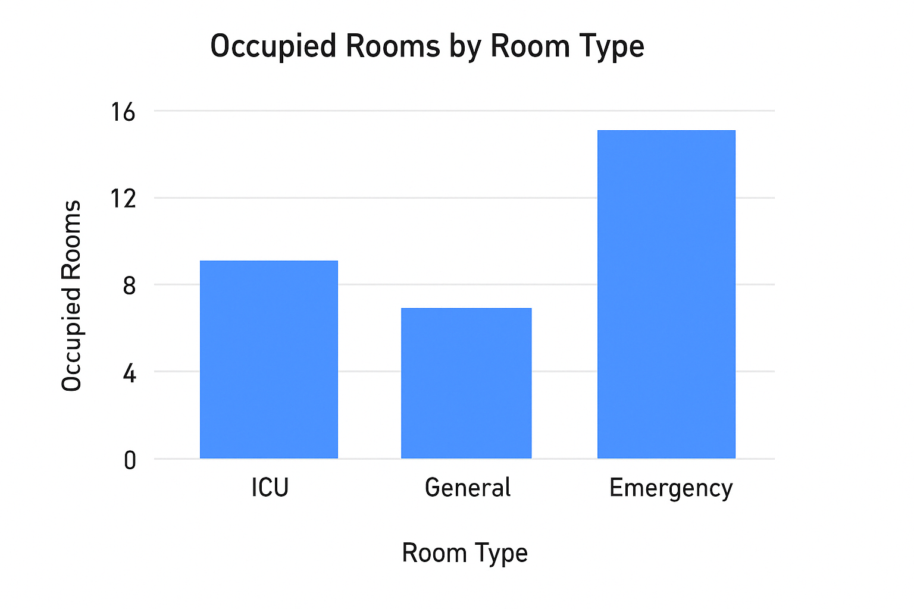

2. Line Graphs
Line graphs are ideal for tracking changes over time and observing trends. These visuals play a critical role in understanding how hospital performance evolves.

Purpose:
To display temporal patterns and trends such as patient inflow or discharge rates.

Use Cases:
- Monthly trend of patient admissions and discharges
- Emergency alert frequencies over time
- ICU usage trend analysis

Benefits:
- Effective at showcasing increases or decreases
- Helps in forecasting and planning resource allocation

Suggested Visual:
Figure 4.2: Line Graph showing monthly patient admissions over six months.

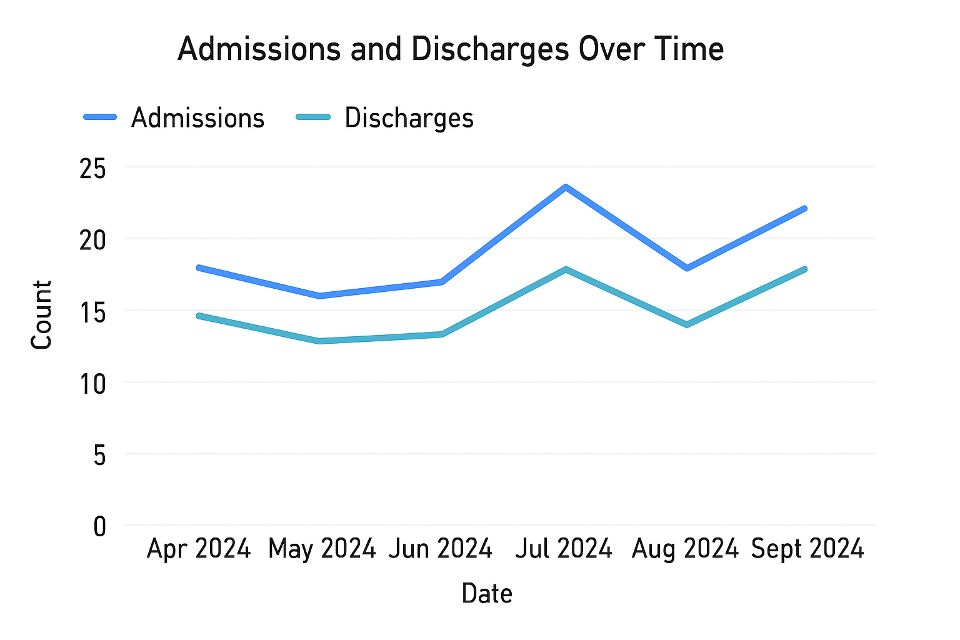
Fig

3. Pie Charts / Donut Charts
Pie charts visually represent the proportion of each component relative to the whole. They are used where the goal is to show part-to-whole relationships.

Purpose:
To display percentage or share of a category within a dataset.

Use Cases:
- Distribution of room statuses (Available, Occupied, Under Maintenance)
- Patient condition categories (Stable, Critical, Under Observation)
- Staff allocation by shift (Morning, Evening, Night)

Benefits:
- Quickly conveys overall proportions
- Useful in executive summaries

Suggested Visual:
Figure 4.3: Donut Chart showing current hospital room status proportions.
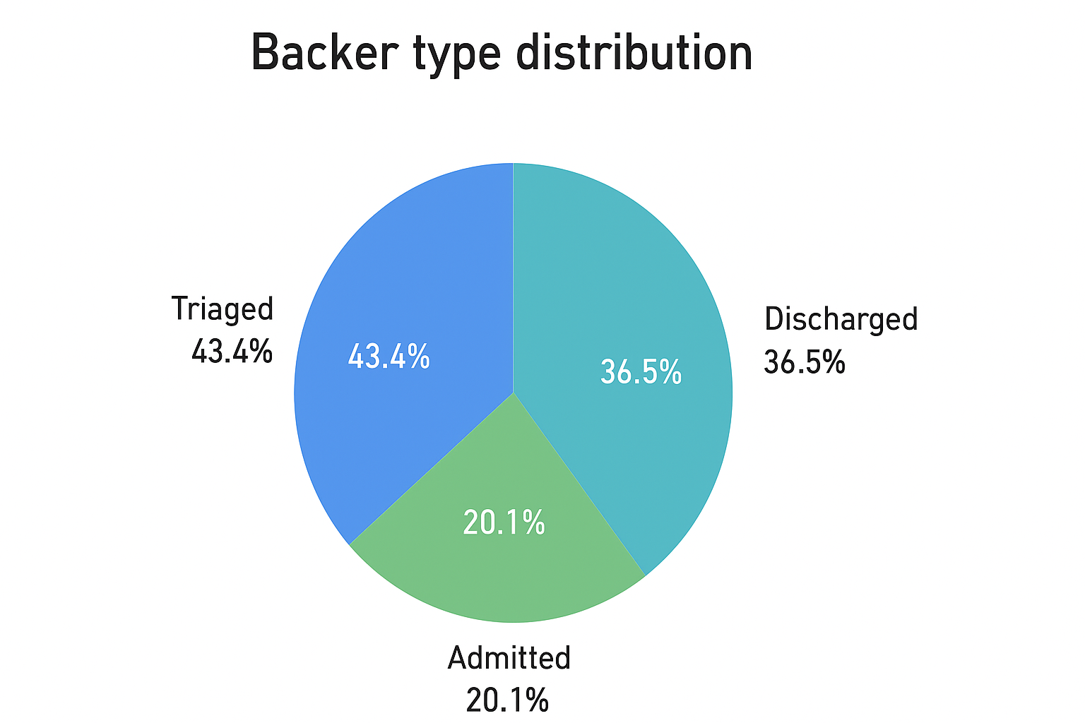

4. Cards and KPIs
KPI cards are used to highlight high-level metrics that decision-makers need to see at a glance. These are usually placed at the top of the report for visibility.

Purpose:
To display key summary metrics in a bold, attention-grabbing format.

Use Cases:
- Total Number of Rooms
- Total Occupied Rooms
- Current Patient Count
- Available ICU Beds
- Staff-to-Patient Ratio

Benefits:
- Instant access to critical performance numbers
- Highly customizable with DAX-based indicators (arrows, trends, alerts)

Suggested Visual:
Figure 4.4: KPI Cards showing key metrics like total patients, available beds, and staff ratio.
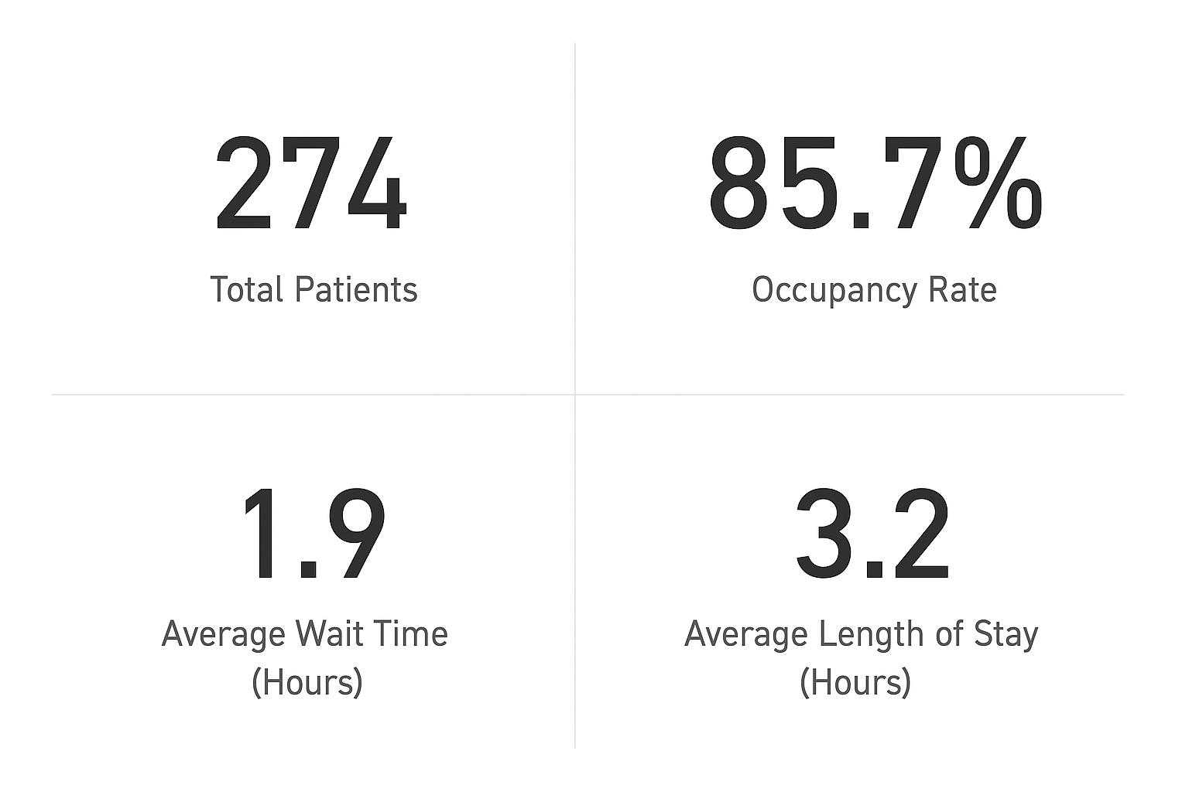

5. Filters & Slicers
Slicers in Power BI are interactive filters that enable users to narrow down data views without modifying the underlying dataset.

Purpose:
To provide user-driven control over how data is viewed on the dashboard.

Use Cases:
- Filter data by Date, Room Type, Floor, or Patient Condition
- Toggle between Staff Departments
- Adjust timeframes to view short-term or long-term trends

Benefits:
- Enhances interactivity and customization
- Allows deep dives into specific segments of data

Suggested Visual:Figure 4.5: Slicer panel allowing filtering by department, shift, and patient status.

6. Heatmaps

If implemented, heatmaps can add spatial intelligence to room allocation — for example, showing room occupancy per floor in a grid layout.

Use Cases:
- Occupancy intensity across hospital floors
- Overcrowding alerts in specific zones
- Time-based traffic flow of patients

Summary Table of Visual Types
Visualization Type | Used For | Section in Dashboard
Bar Chart | Comparing room types, staff counts | Room Overview, Staff Allocation
Line Graph | Trends over time | Patient Admissions
Pie Chart | Proportions (status, categories) | Room Status, Patient Condition
KPI Cards | Summary statistics and key metrics | Home / Overview Page
Slicers & Filters | Interactive data exploration | Entire Dashboard
Heatmaps | Occupancy intensity across locations | Floor Map / Room Level Views

Dashboard Pages Description
The Hospital Room Dashboard has been structured into four primary report pages, each targeting a specific area of hospital operations. This segmentation allows users to analyze critical hospital performance metrics, patient insights, and emergency preparedness efficiently.

Page 1: ER Patient Overview
This page provides a real-time snapshot of the Emergency Room (ER) operations, focusing on room occupancy and patient conditions. It helps emergency staff quickly identify bottlenecks and critical patient cases.

🔹 Key Features:
- KPI Cards: Total ER beds, Occupied Beds, Critical Patients
- Pie Chart: Distribution of patient conditions (Stable, Critical, Under Observation)
- Bar Chart: ER room status by category (Occupied, Available, Maintenance)
- Filters: Room type, Condition, Floor level

Time-based Analysis
This page focuses on temporal trends in hospital data, helping users identify patterns over time such as increases in admissions or fluctuations in ICU usage.

Key Features:
- Line Graph: Daily or monthly patient admissions and discharges
- Bar Chart: Weekly admission distribution
- Slicers: Date range, Department, Room type
- Heatmap (if implemented): Floor-wise occupancy across hours

Figure Reference:
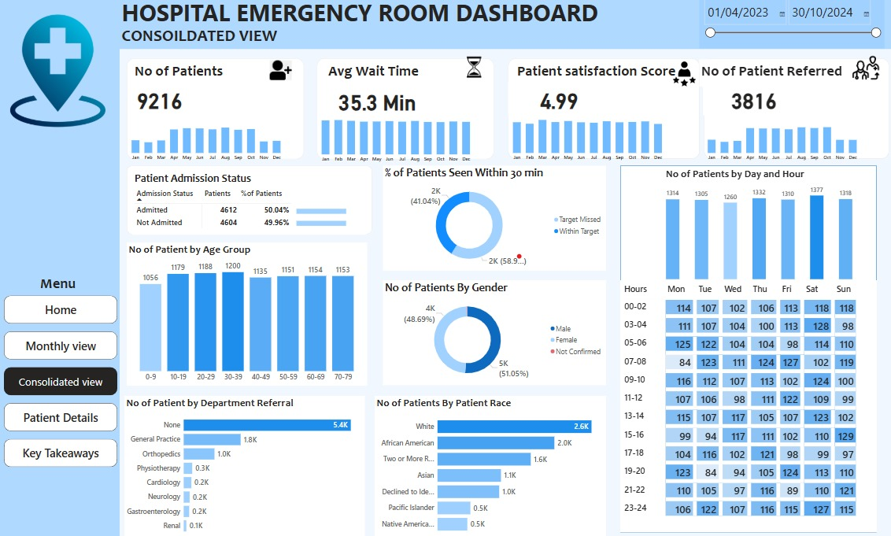

Patient Referrals & Ratings
This page captures the quality-of-care perspective, reflecting how patients were referred and how they rated hospital services post-discharge.

Key Features:
- Pie Chart: Referral sources (Physician, Self, Ambulance)
- Bar Chart: Patient satisfaction by department
- KPI Cards: Total Referrals, Avg. Satisfaction Rating
- Filters: Department, Age Group, Referral Type

Figure Reference:


Page 4: Hospital Performance Metrics
This is a management-focused page that presents high-level performance indicators for strategic decisions. It includes operational efficiency, staff utilization, and room turnover rates.

Key Features:
- KPI Cards: Average Room Turnover Time, Staff-to-Patient Ratio
- Bar Chart: Staff distribution by shift and department
- Donut Chart: Room availability vs. usage
- Slicers: Shift, Department, Room Status

Figure Reference:


DAX Measures and Calculations
DAX (Data Analysis Expressions) is the powerful formula language used in Power BI to create custom calculations, aggregations, and logic-based insights from data models. In the Hospital Room Dashboard, DAX enables dynamic analysis and real-time metric computation across various parameters like time, department, and patient status.

Custom Measures
Custom DAX measures were used to calculate key metrics tailored to hospital operations. These measures provide flexibility and granularity for analysis, ensuring precise tracking of data like occupancy rates and patient inflow.

Examples:
Total Occupied Beds
DAX
TotalOccupiedBeds = CALCULATE(COUNTROWS(RoomData), RoomData[Status] = "Occupied")

Available Beds Count
DAX
AvailableBeds = CALCULATE(COUNTROWS(RoomData), RoomData[Status] = "Available")

Critical Patient Count
DAX
CriticalPatients = CALCULATE(COUNTROWS(PatientData), PatientData[Condition] = "Critical")

Time Intelligence
Time-based DAX functions allow the dashboard to analyze patient and room activity across different time periods (daily, weekly, monthly). This enables trend spotting, forecasting, and operational adjustments based on historical data.

Examples:
Monthly Admissions
DAX
MonthlyAdmissions = CALCULATE(COUNT(PatientData[PatientID]), DATESMTD(DateTable[Date]))

Previous Month Occupancy
DAX
PrevMonthOccupancy = CALCULATE([TotalOccupiedBeds], PREVIOUSMONTH(DateTable[Date]))

Admission Growth %
DAX
AdmissionGrowth =
DIVIDE(
[MonthlyAdmissions] - [PrevMonthAdmissions],
[PrevMonthAdmissions],
0
)

KPIs Logic
Key Performance Indicators (KPIs) were developed using DAX to provide quick status indicators for hospital efficiency, resource usage, and patient care quality.
Examples:
Room Occupancy Rate %
DAX
CopyEdit
RoomOccupancyRate =
DIVIDE([TotalOccupiedBeds], [TotalBeds], 0)

Average Length of Stay (LOS)
DAX
AvgLOS = AVERAGE(PatientData[LengthOfStay])

Patient Satisfaction Score
DAX
AvgSatisfaction = AVERAGE(SurveyData[Rating])

Staff-to-Patient Ratio
DAX
StaffToPatientRatio =
DIVIDE(COUNTROWS(StaffData), COUNTROWS(PatientData))

Insights & Interpretation
The Hospital Room Dashboard is designed not just to present data but to derive actionable insights that support hospital administrators and emergency staff in decision-making. Below is a detailed interpretation of the key patterns and trends derived from the dashboard visuals.

Patient Volume Trends
Analysis of patient admissions and discharges over time reveals significant fluctuations in hospital load. Using time-series data visualizations (line graphs), we observed patterns that help predict future spikes or drops in volume.
- Admissions tend to increase during weekdays, particularly Mondays and Tuesdays, and decline slightly over the weekends.
- A noticeable increase in emergency admissions was recorded during late evenings, suggesting a need for resource allocation during those times.
- There is a gradual upward trend in monthly admissions, indicating growing reliance on the hospital's emergency department.
These trends assist in forecasting and better planning of staff deployment, bed allocation, and supply chain needs.

Peak Hours Analysis
The dashboard highlights specific time windows where hospital activity intensifies. These insights are derived from patient check-in timestamps and bed occupancy logs.
- Peak ER activity typically occurs between 6 PM and 10 PM, aligning with post-work hours when individuals are more likely to seek emergency care.
- ICU occupancy is highest between 11 AM and 2 PM, possibly due to transfers from other departments or post-surgery monitoring.
- The lowest activity is observed in the early morning hours (3 AM to 6 AM), which could be considered for system maintenance or low-priority tasks.
Understanding these peak hours helps in improving operational efficiency, reducing patient wait times, and ensuring staff readiness.

Hospital Efficiency
Several KPIs were developed to track the efficiency of the hospital operations. Metrics like bed turnover rate, room occupancy percentage, and staff-to-patient ratio reveal important operational insights.
- The average room occupancy rate remained above 85%, indicating high utilization but also limited flexibility in times of surges.
- The average room turnover time was around 2.5 hours, showing relatively fast readiness for new patients, but with some variations across departments.
- Staff-to-patient ratio was optimal during the day shifts but dropped below target during night shifts, signaling potential understaffing issues.
These insights help management in resource reallocation and efficiency improvements across departments.

Feedback and Ratings
Patient satisfaction ratings and referral sources provide insights into the quality of care and the hospital's reputation in the community.
- Most referrals were from in-network physicians and ambulance services, confirming strong professional trust in the hospital.
- Patient satisfaction averaged 4.2 out of 5, with high scores in cleanliness and doctor-patient communication but lower scores in wait times.
- Department-wise analysis showed the Pediatrics and Cardiology units received the highest ratings, while General Ward had slightly lower feedback due to bed availability concerns.
These insights are valuable for hospital leadership to improve service delivery and address concerns in underperforming departments.

Challenges Faced
During the development of the Hospital Room Dashboard, several technical and analytical challenges were encountered. These challenges were related to data quality, tool limitations, and performance constraints within Power BI. Addressing these effectively was critical to delivering an accurate, responsive, and insightful dashboard.

Data Issues
The raw data obtained from different hospital systems came with inconsistencies that required significant pre-processing before it could be visualized effectively.
- Missing and Incomplete Records:
Several entries had missing values for patient conditions, room statuses, or timestamps. This hindered trend analysis and KPIs involving patient tracking or occupancy rates.
- Data Formatting Problems:
Some date fields were in inconsistent formats (e.g., DD/MM/YYYY vs. MM/DD/YYYY), and numeric fields (like satisfaction ratings) were incorrectly stored as text, causing issues during DAX calculations.
- Non-standard Terminology:
Variations in categorical values (e.g., "Available", "Vacant", "Open") for the same status had to be standardized using data transformations to ensure accurate aggregation.
- Duplicate Records:
Repeated entries, especially in the patient admission logs, skewed metrics like total admissions or length of stay until they were removed.
These issues were resolved using Power Query and Excel preprocessing steps, ensuring the dataset was clean and consistent.

Performance in Power BI
As the dataset grew in size and complexity, certain performance bottlenecks appeared during dashboard rendering and interaction.
- Slow Report Load Time:
Multiple visuals, especially on pages with time-based trends and filters, increased load time significantly. This was improved by optimizing DAX queries and limiting the number of simultaneous visuals.
- Memory Consumption:
Using multiple calculated columns and unoptimized relationships in the data model initially consumed a high amount of memory, which slowed down refresh times.
- Slicer Interaction Lag:
Applying multiple slicers (e.g., room status, patient condition, department) caused a lag due to the dynamic nature of cross-filtering large datasets.
- Auto Date/Time Feature:
Power BI’s default auto-generated time hierarchies were consuming resources. Disabling the feature and using a dedicated Date Table improved performance and allowed for more accurate time intelligence.
To overcome these issues, best practices such as data model normalization, measure optimization, and use of summary tables were followed.

Solutions Implemented
To address the data and performance-related challenges faced during the development of the Hospital Room Dashboard, a number of corrective measures and optimizations were implemented. These steps helped ensure the dashboard was accurate, efficient, and user-friendly.

Data Cleaning and Standardization
- Power Query Editor was extensively used to clean and preprocess data.
- Missing values were handled using conditional replacements or removed if irrelevant.
- Text fields (like patient condition or room status) were standardized using "Replace Values" and conditional columns to unify categories.
- Duplicate records were removed using key column checks to ensure accuracy in counts and KPIs.

Optimized Data Modeling
- Relationships were carefully designed between fact and dimension tables to ensure a star schema, reducing query complexity.
- Lookup tables for room types, departments, dates, and patient categories were introduced to minimize redundancy.
- Calculated columns were reduced or replaced with measures wherever possible to improve memory usage.

DAX Optimization
- Complex logic was encapsulated into reusable measures instead of repeating calculations across visuals.
- Filters were applied at the measure level using CALCULATE and FILTER instead of applying them across the whole page, which improved responsiveness.
- Time intelligence functions were based on a custom date table, allowing better performance and more accurate temporal analysis.

Performance Enhancements in Power BI
- Disabled Auto Date/Time Hierarchies in Power BI options to reduce background processing overhead.
- Used summary tables and aggregation layers to minimize the load on visuals displaying large datasets.
- Limited the number of visuals per page and used drill-through pages to reduce rendering time.
- Removed unused columns and tables from the data model to improve overall file size and refresh speed.

User Interface Improvements
- Implemented slicer panels with clearly defined filters, reducing user confusion and interaction delays.
- Introduced bookmarks and navigation buttons to help users move smoothly between dashboard pages.
- Used a consistent layout and color scheme to make visual interpretation intuitive.

Conclusion
The Hospital Room Dashboard developed using Power BI provides a powerful, data-driven solution to monitor and manage emergency room operations and hospital performance. Through comprehensive visualizations and real-time insights, the dashboard enhances situational awareness, supports critical decision-making, and helps streamline healthcare service delivery.
This project demonstrates how integrating multiple data sources, applying effective data transformation techniques, and leveraging DAX calculations can result in a highly functional and informative dashboard. Key hospital metrics such as room occupancy, patient admissions, referral tracking, and staff-to-patient ratios are clearly presented through an interactive and user-friendly interface.
Despite initial challenges related to data quality and dashboard performance, solutions like optimized data models, custom measures, and improved interface design ensured the final outcome was both robust and scalable.
In summary, the dashboard meets its core objectives:
- Enables quick monitoring of ER and hospital room usage
- Tracks critical KPIs such as patient flow and efficiency metrics
- Supports proactive staffing and resource management
- Offers an intuitive platform for both administrative and medical personnel
This project not only improves operational transparency but also lays the foundation for future data-driven enhancements in hospital management.

Future Scope
While the current version of the Hospital Room Dashboard effectively delivers real-time insights and operational monitoring, there is considerable scope for expansion and enhancement in future iterations. The following areas present opportunities for improvement and added value:

1. Integration with Live Hospital Systems
- Future versions can be connected directly to live hospital databases or hospital management systems (HMS) for real-time updates.
- API-based integration would allow for continuous syncing of room statuses, admissions, discharges, and patient feedback.

2. Advanced Predictive Analytics
- Incorporating machine learning models within Power BI (via Python or R scripts) could enable predictions such as:
  - Expected room occupancy for upcoming days
  - Patient inflow based on seasonal trends
  - Staffing needs based on historic load patterns

3. Real-time Alerts & Notifications
- Implementing Power BI's Power Automate integration can trigger email or SMS alerts when KPIs exceed defined thresholds.
- For example, alerts can notify the staff when room occupancy exceeds 90% or when a critical patient arrives.

4. Enhanced User Personalization
- Role-based dashboards can be developed so that:
  - Doctors see patient condition summaries and tasks
  - Administrators see KPIs and efficiency metrics
  - Nurses view bed availability and shift-related data

5. Patient-Level Drill Down
- The dashboard could be expanded to allow patient-level analysis, such as:
  - Detailed timelines of a patient’s journey through different departments
  - Case histories and real-time updates for doctors on rounds

6. Mobile-Friendly or App-Based Dashboard
- Creating a Power BI mobile layout or a dedicated app will enable hospital staff to view key insights on smartphones or tablets during ward rounds.

7. Data Privacy & Security Enhancements
- Future development should consider data encryption, access control, and compliance with healthcare privacy regulations (like HIPAA or GDPR).
- User activity tracking can also be introduced to maintain transparency and audit trails.
By addressing these future improvements, the Hospital Room Dashboard can evolve from a monitoring tool into a fully integrated, predictive, and strategic asset in hospital management and healthcare delivery.

Appendices

Appendix A: Screenshots of All Dashboard Pages
ER Patient details
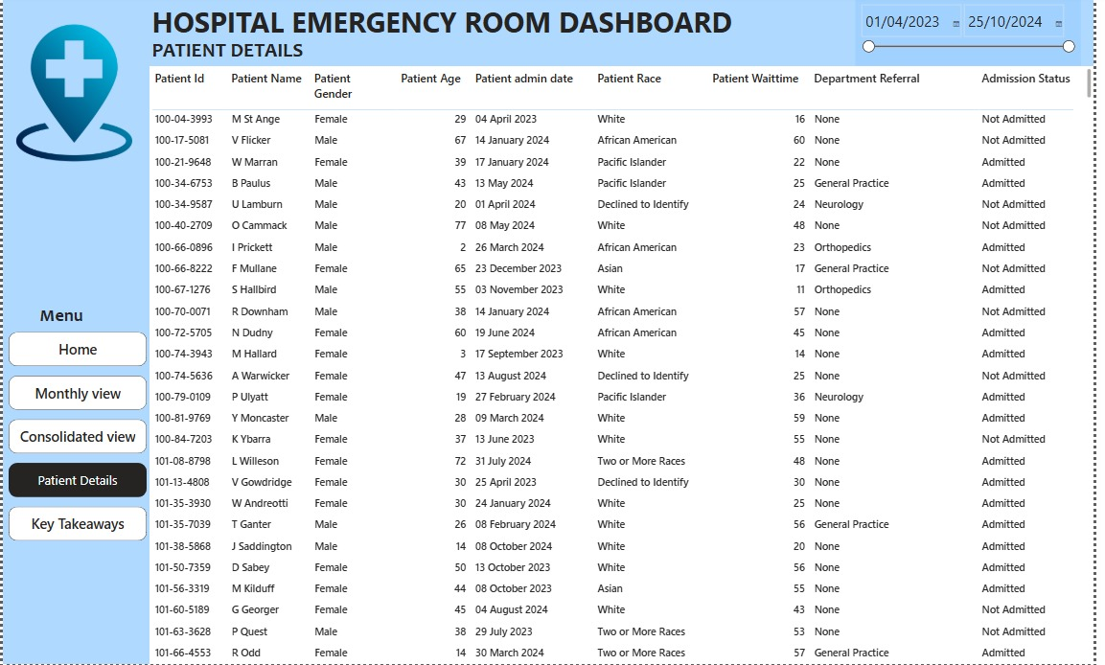
Page 2 Time-based Analysis
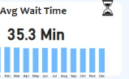

Page 3: Patient Referrals & Ratings
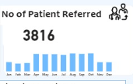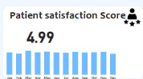
Page 4: Hospital Performance Metrics



Appendix B: DAX Code Snippets
Below are key DAX formulas used in various parts of the dashboards:
1. Total ER Visits
dax
Total ER Visits = COUNT('PatientData'[PatientID])

2. Average Wait Time (Minutes)
dax

Avg Wait Time = AVERAGE('PatientData'[WaitTime])

3. Monthly Admissions
dax

Monthly Admissions =
CALCULATE(
COUNT('PatientData'[PatientID]),
FILTER('PatientData', MONTH('PatientData'[AdmissionDate]) = MONTH(TODAY()))
)

4. Patient Referral Rate
dax

Referral Rate =
DIVIDE(
COUNTROWS(FILTER('PatientData', 'PatientData'[Referred] = TRUE())),
COUNT('PatientData'[PatientID])
)

5. Hospital Room Utilization (%)
dax

Room Utilization =
DIVIDE(
SUM('RoomUsage'[HoursUsed]),
SUM('RoomUsage'[TotalAvailableHours])
)

Appendix C: Data Dictionary
Column Name | Data Type | Description
PatientID | Integer | Unique identifier for each patient
AdmissionDate | Date | Date of patient admission
DischargeDate | Date | Date of patient discharge
WaitTime | Integer | Wait time in minutes before treatment
RoomID | Text | Identifier for the hospital room
HoursUsed | Integer | Number of hours a room was used
TotalAvailableHours | Integer | Total number of hours a room was available
Referred | Boolean | Indicates whether the patient was referred
PatientRating | Decimal | Rating provided by the patient (1 to 5 scale)
Department | Text | Hospital department assigned to the patient
ConditionSeverity | Text | Severity level of patient’s condition

References
- Microsoft Power BI Documentation. (2024). DAX Basics in Power BI. Retrieved from https://learn.microsoft.com/en-us/power-bi/transform-model/desktop-dax-basics
- Centers for Disease Control and Prevention. (2023). Emergency Department Data. Retrieved from https://www.cdc.gov/nchs/fastats/emergency-department.htm
- HealthIT.gov. (2023). Hospital Performance Metrics and Analytics. Retrieved from https://www.healthit.gov
- Power BI Community Forums. (2024). Solutions for Healthcare Dashboards. Retrieved from https://community.powerbi.com
- Data.gov. (2023). Hospital Utilization and Admissions Data. Retrieved from https://healthdata.gov

